*eyeRobot* User Documentation Guide

By: Kevinphi Hoang, Rachel Palmer, Eddie Penta

**Overview:**

Artificial intelligence has always been a topic of interest in the software development world- however, the goal of this project is to create a robot that can assist in daily struggles. If eyeRobot can perform to the caliber envisioned, the result would be life-changing for blind individuals who cannot afford a service solution. eyeRobot will be able to travel from point A to point B without colliding with any obstacles in its path. In addition to this, the robot should be able to detect and recognize said obstacles and alert us of the varying objects. Currently in the general market, there are no real *service* robots available; the ones available to the public are designed only to perform “dirty” or repetitive tasks, such as ordinary household chores. An optimal eyeRobot is anticipated to be able to run its own market for artificial, automated assistive technology for the blind.

**What You Need:**

To get started using your eyeRobot, you will need to have the physical robot which comes equipped with four wheels and motors, a Raspberry Pi 3, a depth camera, gyroscope, and battery packs. The Raspberry Pi should come preloaded with the latest Raspbian OS along with the software needed to receive the commands sent from your computer. On the computer that you wish to run the AI script, you will need Python 3.6 or later installed, and the latest JRE. You should also have Unity 5 installed. There are several Python libraries that you will need to have installed. These include Keras, OpenAI gym, Open Kinect, and plaidML, Tensorflow, and threespace. For the Java server, you will need Netty as well.

**Instructions:**

You will need to connect your eyeRobot and computer to the same network. Once connected, you must start the Java server.

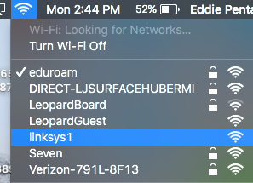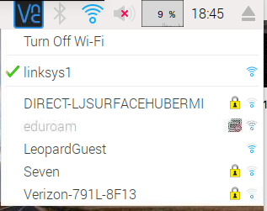

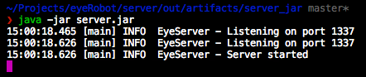

Next open *config.py* and change the server IP to match the IP of the computer running the Java server

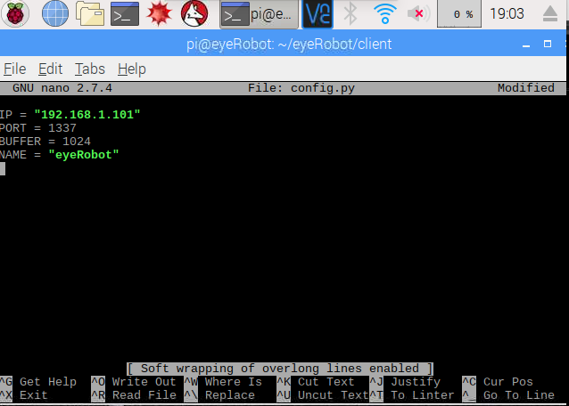

Set the eyeRobot in a desirable starting position and run the *server_motor.py* script on the Raspberry Pi.

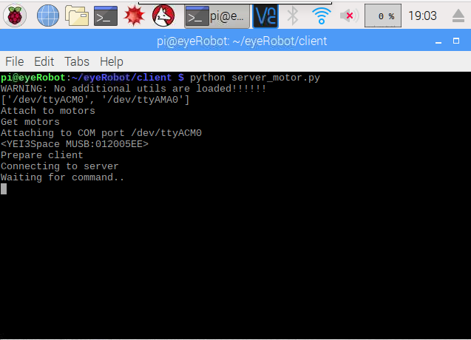

You should see it connect in the Java server.

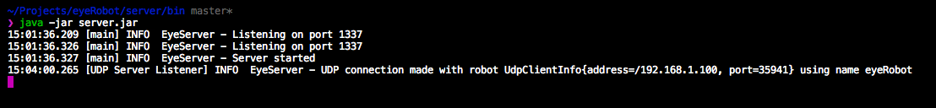

Next, load the Unity scene to load the virtual environment.

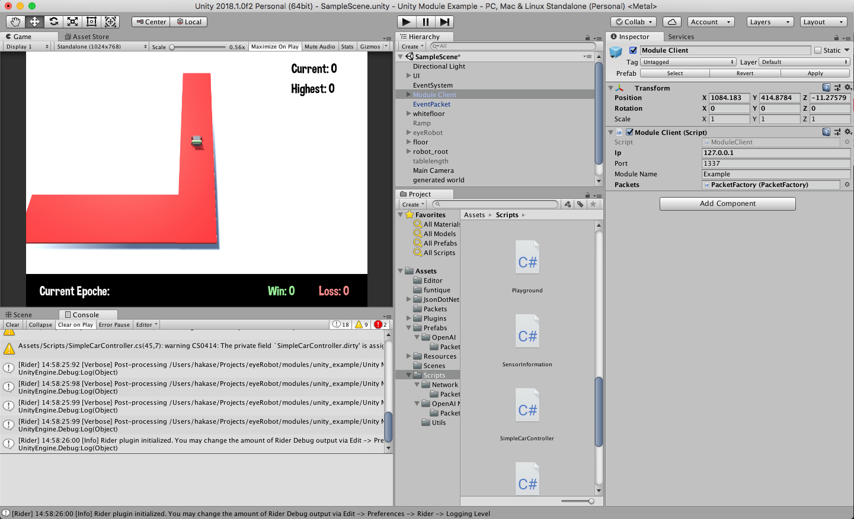

And hit play

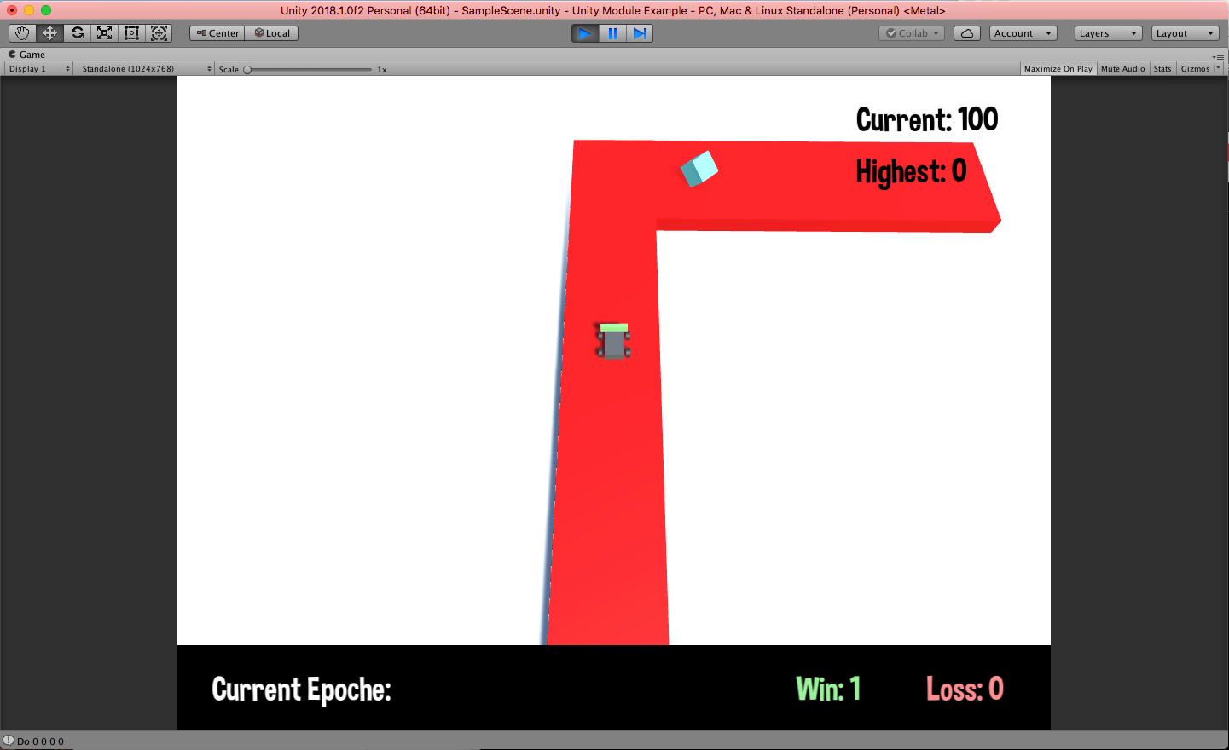

You should see the Unity module connect to the Java server named “Example”

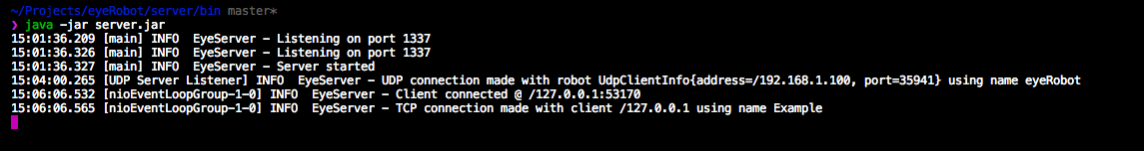

Then, you must run the *eyeRobot_AI.py* script to begin training. When the script first starts, it will ask you if you would like to load a previous model, type no to train a new model. After running the script, you will be presented with many choices for what you would like to do. Pressing ‘r’ will run a single episode and pressing ‘s’ will run 100 episodes without stopping. Pressing ‘g’ will graph the current error rate. Finally, pressing ‘q’ will quit the script and ask to save the current AI to a file.

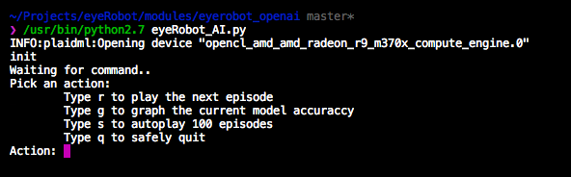

When Unity and the eyeRobot_AI.py script are running, you should see the following output:

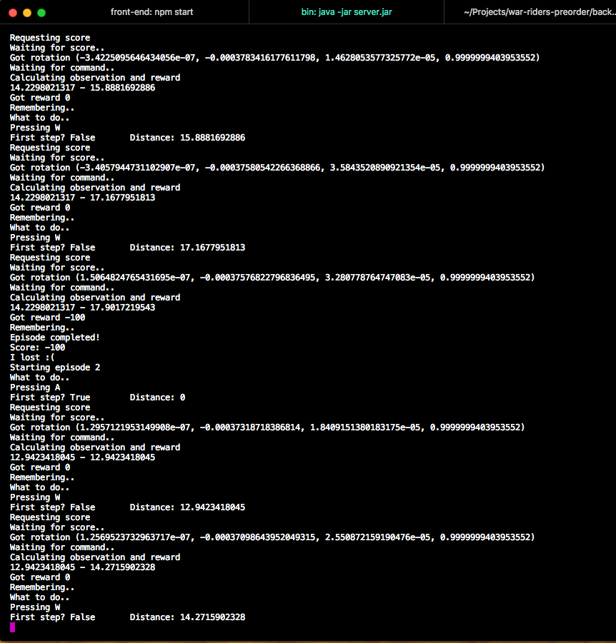

The robot will train itself on this environment. Be warned that this training process will take several hours and will train better without moving objects (such as humans and pets) in its environment. eyeRobot will train best in complete solitude.

Once trained, eyeRobot will finish moving around. You can move onto the next phase by loading the recently saved model.

Once you have successfully loaded your saved AI training, you will have completed the User Documentation Guide! We hope that you enjoy using eyeRobot.